EXPERIMENT NO.1

TITLE: IMPLEMENTATION OF CAESAR CIPHER
AIM:To implement the simple substitution technique named Caesar cipher using C language.

DESCRIPTION:
To encrypt a message with a Caesar cipher, each letter in the message is changed using a simple rule: shift by three. Each letter is replaced by the letter three letters ahead in the alphabet. A becomes D, B becomes E, and so on. For the last letters, we can think of alphabet as a circle and "wrap around". W becomes Z, X becomes A, Y becomes B, and Z becomes C. To change a message back, each letter is replaced by the one three before it.
EXAMPLE:

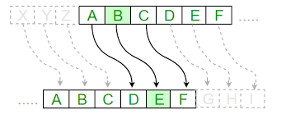

ALGORITHM:
STEP-1: Read the plain text from the user.
STEP-2: Read the key value from the user.
STEP-3: If the key is positive then encrypt the text by adding the key with each character in the plain text.
STEP-4: Else subtract the key from the plain text.
STEP-5: Display the cipher text obtained above.
PROGRAM : CAESAR CIPHER

#include <stdio.h>
#include <string.h>
#include<conio.h>
#include <ctype.h>
int main()
{
char plain[10], cipher[10];
intkey,i,length;
int result;

printf("\n Enter the plain text:");
scanf("%s", plain);
printf("\n Enter the key value:");
scanf("%d", &key);
printf("\n \n \t PLAIN TEXt: %s",plain);
printf("\n \n \t ENCRYPTED TEXT: ");
for(i = 0, length = strlen(plain); i < length; i++)
{
cipher[i]=plain[i] + key;
if (isupper(plain[i]) && (cipher[i] > 'Z'))
cipher[i] = cipher[i] - 26;
if (islower(plain[i]) && (cipher[i] > 'z'))
cipher[i] = cipher[i] - 26;
printf("%c", cipher[i]);
}
printf("\n \n \t AFTER DECRYPTION : ");
for(i=0;i<length;i++)
{
plain[i]=cipher[i]-key;
if(isupper(cipher[i])&&(plain[i]<'A'))
plain[i]=plain[i]+26;
if(islower(cipher[i])&&(plain[i]<'a'))
plain[i]=plain[i]+26;
printf("%c",plain[i]);
}
getch();
}
OUTPUT:

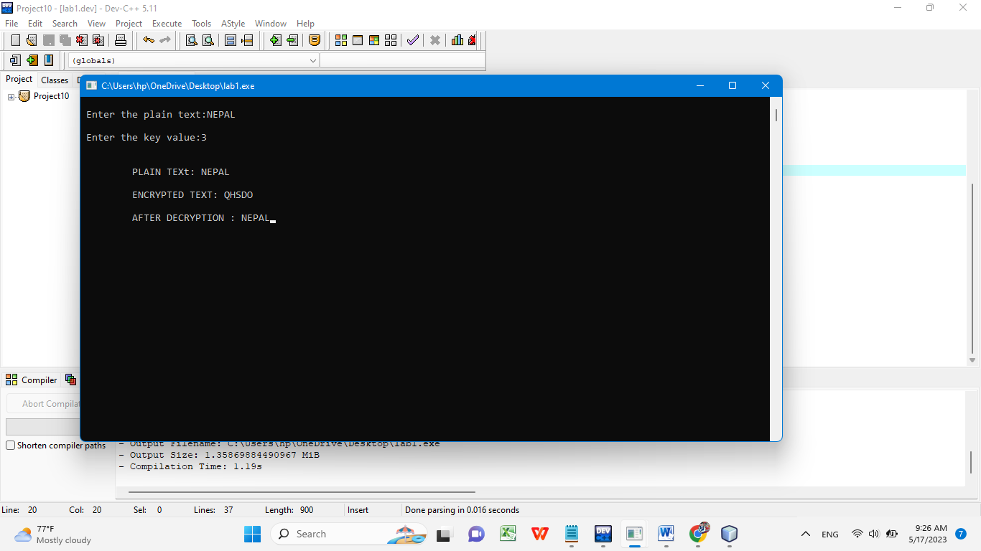
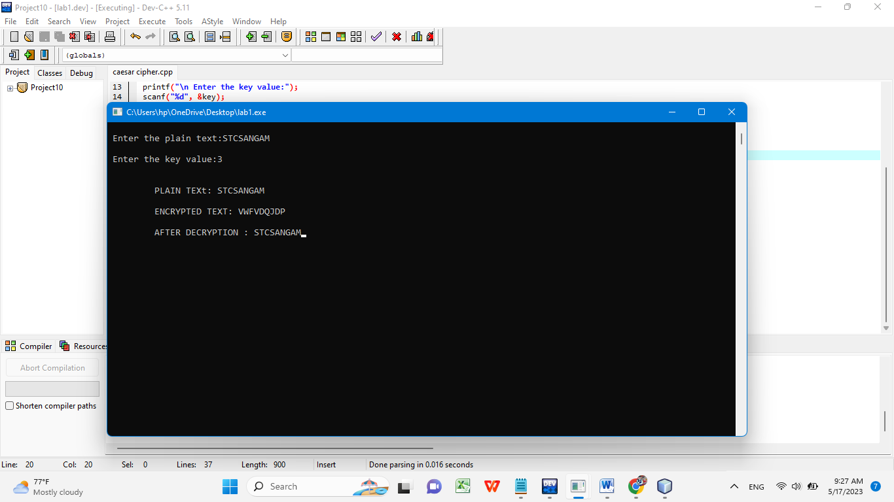
RESULT:Thus the implementation of Caesar cipher had been executed successfully.
EXPERIMENT NO.2

TITLE:IMPLEMENTATION OF PLAYFAIR CIPHER
AIM:To write a C program to implement the Playfair Substitution technique.

DESCRIPTION:
The Playfair cipher starts with creating a key table. The key table is a 5×5 grid of letters that will act as the key for encrypting your plaintext. Each of the 25 letters must be unique and one letter of the alphabet is omitted from the table (as there are 25 spots and 26 letters in the alphabet).
To encrypt a message, one would break the message into diagrams (groups of 2 letters) such that, for example, "HelloWorld" becomes "HE LL OW OR LD", and map them out on the key table. The two letters of the diagram are considered as the opposite corners of a rectangle in the key table. Note the relative position of the corners of this rectangle. Then apply the following 4 rules, in order, to each pair of letters in the plaintext: 1. If both letters are the same (or only one letter is left), add an "X" after the first letter 2. If the letters appear on the same row of your table, replace them with the letters to their immediate right respectively 3. If the letters appear on the same column of your table, replace them with the letters immediately below respectively 4. If the letters are not on the same row or column, replace them with the letters on the same row respectively but at the other pair of corners of the rectangle defined by the original pair.

EXAMPLE:
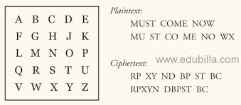

ALGORITHM:
STEP-1: Read the plain text from the user.
STEP-2: Read the keyword from the user.
STEP-3: Arrange the keyword without duplicates in a 5*5 matrix in the row order and fill the remaining cells with missed out letters in alphabetical order. Note that ‘i’ and ‘j’ takes the same cell.
STEP-4: Group the plain text in pairs and match the corresponding corner letters by forming a rectangular grid.
STEP-5: Display the obtained cipher text.

PROGRAM: PLAYFAIR CIPHER

#include<stdio.h>
#include<conio.h>
#include<string.h>
#include<ctype.h>
#define MX 5
voidplayfair(char ch1,char ch2, char key[MX][MX])
{
inti,j,w,x,y,z;
FILE *out;
if((out=fopen("cipher.txt","a+"))==NULL)
{
printf("File Currupted.");
}
for(i=0;i<MX;i++)
{
for(j=0;j<MX;j++)
{
if(ch1==key[i][j])
{
w=i;
x=j;
}
else if(ch2==key[i][j])
{
y=i;
z=j;
}}}
//printf("%d%d %d%d",w,x,y,z);
if(w==y)
{
x=(x+1)%5;z=(z+1)%5;
printf("%c%c",key[w][x],key[y][z]);
fprintf(out, "%c%c",key[w][x],key[y][z]);
}
else if(x==z)
{
w=(w+1)%5;y=(y+1)%5;
printf("%c%c",key[w][x],key[y][z]);
fprintf(out, "%c%c",key[w][x],key[y][z]);
}
else
{
printf("%c%c",key[w][z],key[y][x]);
fprintf(out, "%c%c",key[w][z],key[y][x]);
}
fclose(out);
}
int main()
{
inti,j,k=0,l,m=0,n;
char key[MX][MX],keyminus[25],keystr[10],str[25]={0};
char
alpa[26]={'A','B','C','D','E','F','G','H','I','J','K','L'
,'M','N','O','P','Q','R','S','T','U','V','W','X','Y','Z'}
;

printf("\nEnter key:");
gets(keystr);
printf("\nEnter the plain text:");
gets(str);
n=strlen(keystr);
//convert the characters to uppertext
for (i=0; i<n; i++)
{
if(keystr[i]=='j')keystr[i]='i';
else if(keystr[i]=='J')keystr[i]='I';
keystr[i] = toupper(keystr[i]);
}
//convert all the characters of plaintext to uppertext
for (i=0; i<strlen(str); i++)
{
if(str[i]=='j')str[i]='i';
else if(str[i]=='J')str[i]='I';
str[i] = toupper(str[i]);
}
j=0;
for(i=0;i<26;i++)
{
for(k=0;k<n;k++)
{
if(keystr[k]==alpa[i])
break;
else if(alpa[i]=='J')
break;
}
if(k==n)
{
keyminus[j]=alpa[i];j++;
}
}
//construct key keymatrix
k=0;
for(i=0;i<MX;i++)
{
for(j=0;j<MX;j++)
{
if(k<n)
{
key[i][j]=keystr[k];
k++;}
else
{
key[i][j]=keyminus[m];m++;
}
printf("%c ",key[i][j]);
}
printf("\n");
}
printf("\n\nEntered text :%s\nCipher Text :",str);
for(i=0;i<strlen(str);i++)
{
if(str[i]=='J')str[i]='I';
if(str[i+1]=='\0')
playfair(str[i],'X',key);
else
{
if(str[i+1]=='J')str[i+1]='I';
if(str[i]==str[i+1])
playfair(str[i],'X',key);
else
{
playfair(str[i],str[i+1],key);i++;
}}
}
getch();
}
OUTPUT:

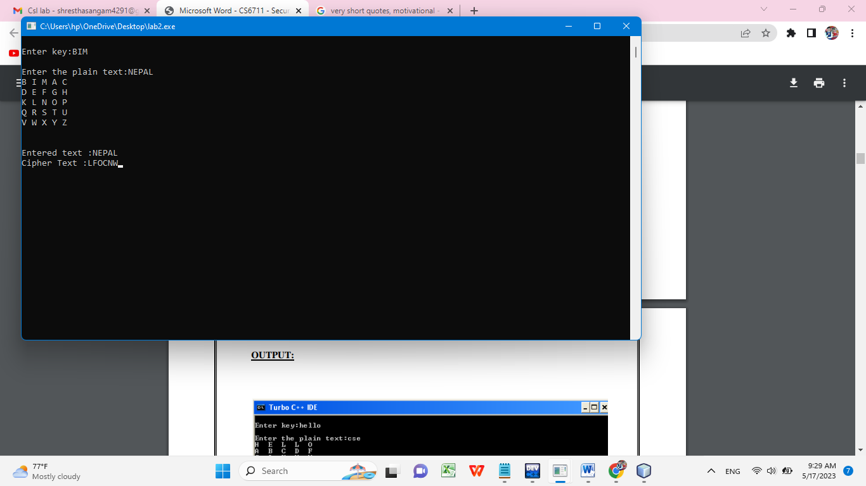
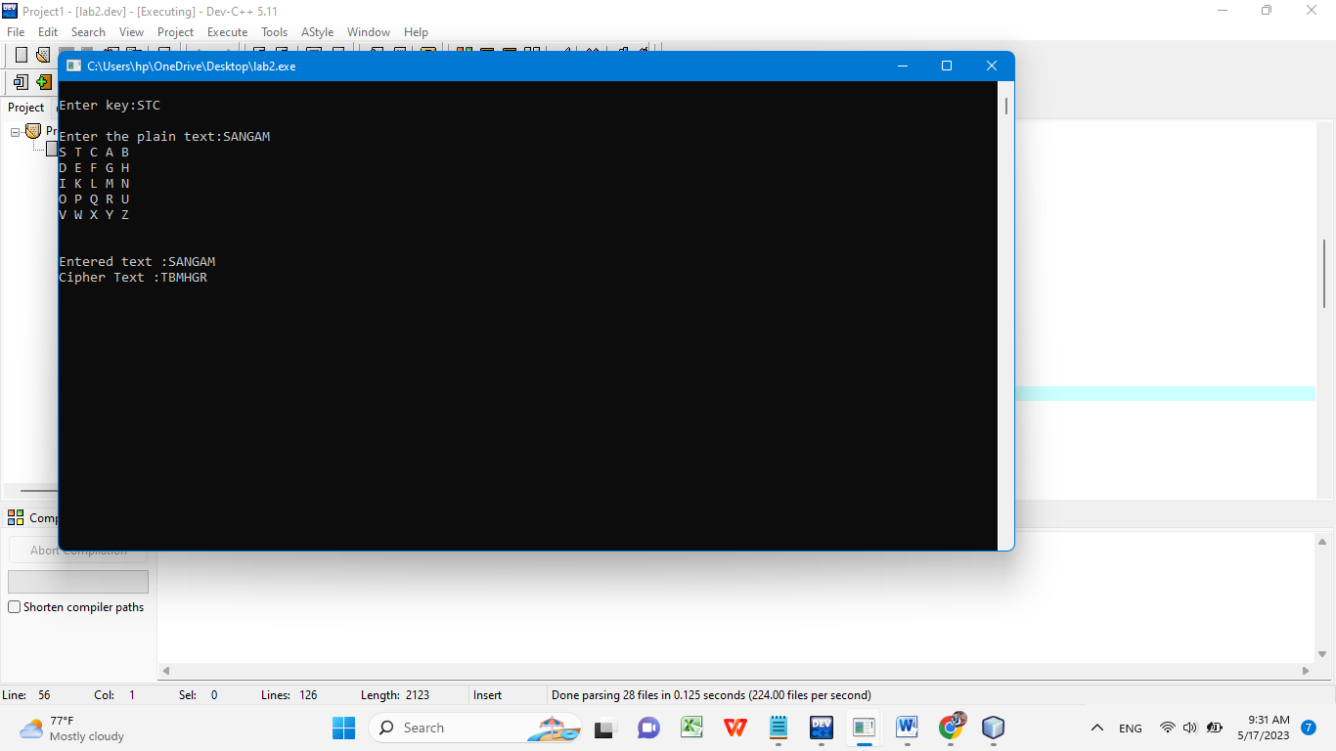

RESULT: Thus the Playfair cipher substitution technique had been implemented successfully

EXPERIMENT NO.3

TITLE:IMPLEMENTATION OF HILL CIPHER

AIM:To write a C program to implement the hill cipher substitution techniques.

DESCRIPTION:
The Hill Cipher is also a block cipher. A block cipher is an encryption method that implements a deterministic algorithm with a symmetric key to encrypt a block of text. It doesn't need to encrypt one bit at a time like in stream ciphers

EXAMPLE:

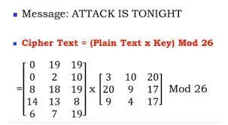

ALGORITHM:

STEP-1: Read the plain text and key from the user.
STEP-2: Split the plain text into groups of length three.
STEP-3: Arrange the keyword in a 3*3 matrix.
STEP-4:Multiply the two matrices to obtain the cipher text of length three.
STEP-5:Combine all the groups to get the complete cipher text.

PROGRAM: HILLCIPHER

#include<stdio.h>
#include<conio.h>
#include<string.h>
int main(){
unsigned int a[3][3]={{6,24,1},{13,16,10},{20,17,15}};
unsigned int b[3][3]={{8,5,10},{21,8,21},{21,12,8}};
int i,j, t=0;
unsigned int c[20],d[20];
char msg[20];

printf("Enter plain text:");

scanf("%s",msg);
for(i=0;i<strlen(msg);i++)
{
printf("%d ",c[i]);
}
for(i=0;i<3;i++)
{ t=0;
for(j=0;j<3;j++)
{
t=t+(a[i][j]*c[j]);
}
d[i]=t%26;
}
printf("\nEncrypted Cipher Text :");
for(i=0;i<3;i++)
printf(" %c",d[i]+65);
for(i=0;i<3;i++)
{
t=0;
for(j=0;j<3;j++)
{
t=t+(b[i][j]*d[j]);
}
c[i]=t%26;
}
printf("\nDecrypted Cipher Text :");
for(i=0;i<3;i++)
printf(" %c",c[i]+65);
getch();
return 0;
}

OUTPUT:

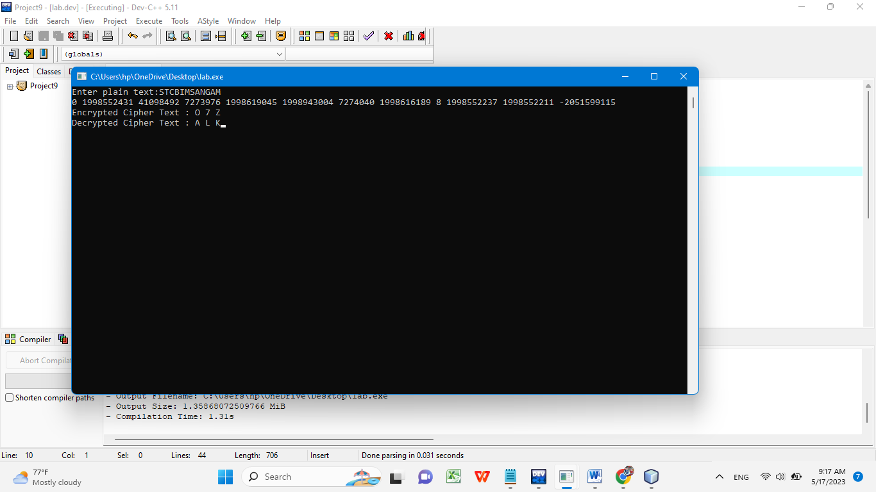

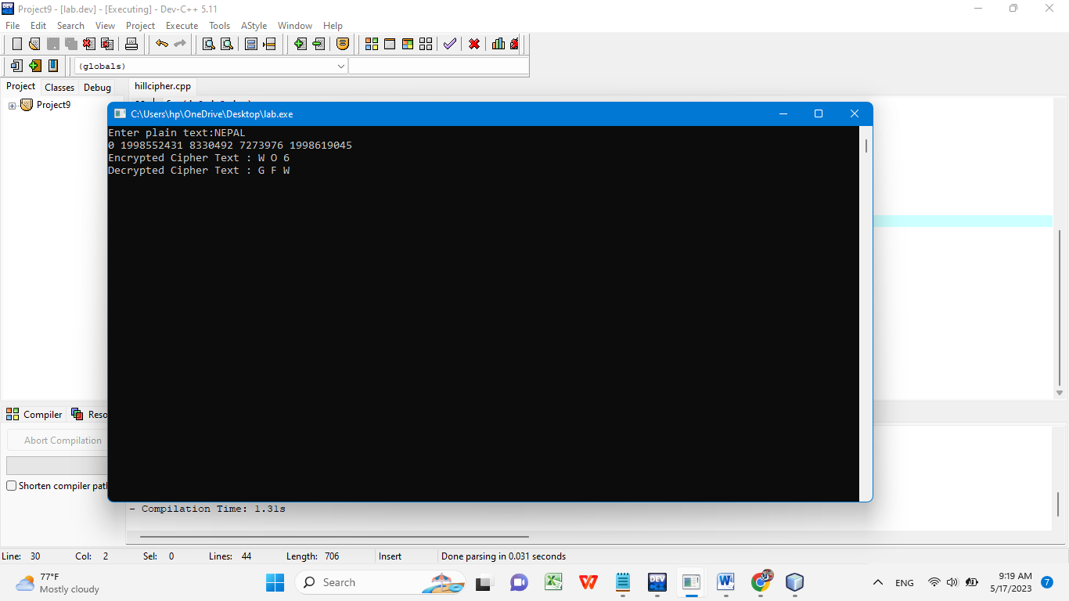

RESULT: Thus the hill cipher substitution technique had been implemented successfully in C.

EXPERIMENT NO. 4

TITLE: IMPLEMENTATION OF VIGENERE CIPHER

AIM: To implement the Vigenere C ipher substitution technique using C program.

DESCRIPTION:
Vigenere Cipher is kind of polyalphabetic substitution method. It is used for encryption of alphabetic text. For encryption and decryption Vigenere Cipher Table is used in which alphabets from A to Z are written in 26 rows.

EXAMPLE:

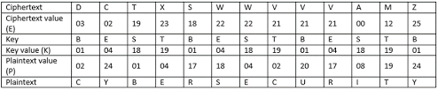

ALGORITHM:

STEP-1: Arrange the alphabets in row and column of a 26*26 matrix.
STEP-2: Circulate the alphabets in each row to position left such that the first letter is attached to last.
STEP-3: Repeat this process for all 26 rows and construct the final key matrix.
STEP-4: The keyword and the plain text is read from the user.
STEP-5: The characters in the keyword are repeated sequentially so as to match with that of the plain text.
STEP-6: Pick the first letter of the plain text and that of the keyword as the row indices and column indices respectively.
STEP-7: The junction character where these two meet forms the cipher character. STEP-8: Repeat the above steps to generate the entire cipher text.

PROGRAM: VIGENERE CIPHER

#include <stdio.h>
#include<conio.h>
#include <ctype.h>
#include <string.h>
void encipher();
void decipher();
int main()
{
int choice;

while(1)
{
printf("\n1. Encrypt Text");
printf("\t2. Decrypt Text");
printf("\t3. Exit");
printf("\n\nEnter Your Choice : ");
scanf("%d",&choice);
if(choice == 3)
return (0);
else if(choice == 1)
encipher();
else if(choice == 2)
decipher();
else
printf("Please Enter Valid Option.");
}}
void encipher()
{
unsignedinti,j;
char input[50],key[10];
printf("\n\nEnter Plain Text: ");
scanf("%s",input);
printf("\nEnter Key Value: ");
scanf("%s",key);
printf("\nResultant Cipher Text: ");
for(i=0,j=0;i<strlen(input);i++,j++)
{
if(j>=strlen(key))
{ j=0;
}
printf("%c",65+(((toupper(input[i])-65)+(toupper(key[j])-
65))%26));
}}
void decipher()
{
unsignedinti,j;
char input[50],key[10];
int value;
printf("\n\nEnter Cipher Text: ");
scanf("%s",input);
printf("\n\nEnter the key value: ");
scanf("%s",key);
for(i=0,j=0;i<strlen(input);i++,j++)
{
if(j>=strlen(key))
{ j=0; }
value = (toupper(input[i])-64)-(toupper(key[j])-64);
if( value < 0)
{ value = value * -1;
}
printf("%c",65 + (value % 26));
}
}
OUTPUT:

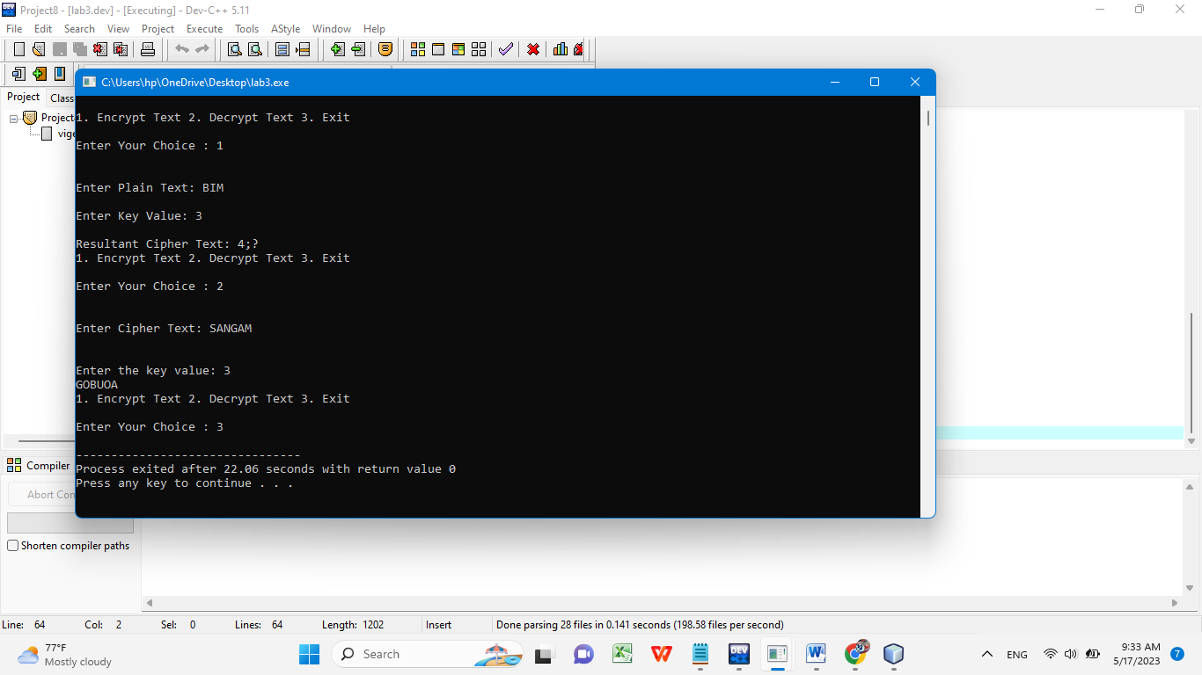
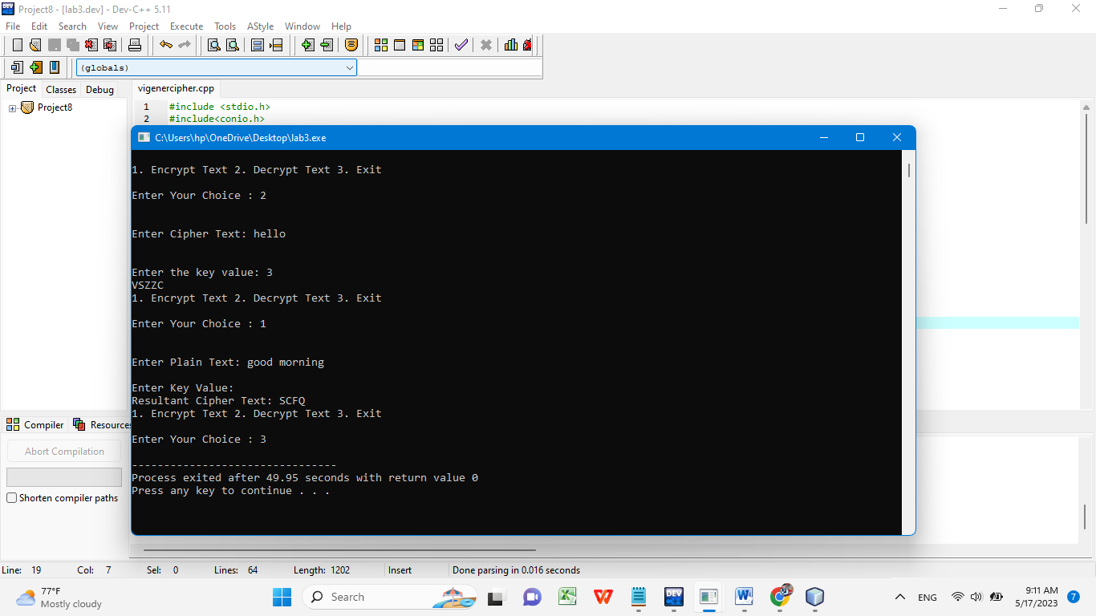

RESULT: Thus the Vigenerecipher substitution technique had been implemented successfully in C.
EXPERIMENT NO. 5

TITLE: IMPLEMENTATION OF RAIL FENCE – ROW & COLUMN TRANSFORMATION TECHNIQUE

AIM: To write a C program to implement the rail fence transposition technique.

DESCRIPTION:
In the rail fence cipher, the plain text is written downwards and diagonally on successive "rails" of an imaginary fence, then moving up when we reach the bottom rail. When we reach the top rail, the message is written downwards again until the whole plaintext is written out. The message is then read off in rows.

EXAMPLE:
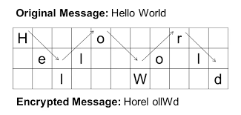

ALGORITHM:
STEP-1: Read the Plain text.
STEP-2: Arrange the plain text in row columnar matrix format.
STEP-3: Now read the keyword depending on the number of columns of the plain text.
STEP-4: Arrange the characters of the keyword in sorted order and the corresponding columns of the plain text.
STEP-5: Read the characters row wise or column wise in the former order to get the cipher text.
PROGRAM: REIL FENCE

#include<stdio.h>
#include<conio.h>
#include<string.h>
int main()
{
int i,j,k,l;
char a[20],c[20],d[20];

printf("\n\t\t RAIL FENCE TECHNIQUE");
printf("\n\nEnter the input string : ");
gets(a);
l=strlen(a);
/*Ciphering*/
for(i=0,j=0;i<l;i++)
{
if(i%2==0)
c[j++]=a[i];
}
for(i=0;i<l;i++)
{
if(i%2==1)
c[j++]=a[i];
}
c[j]='\0';
printf("\nCipher text after applying rail fence :");
printf("\n%s",c);
/*Deciphering*/
if(l%2==0)
k=l/2;
else
k=(l/2)+1;
for(i=0,j=0;i<k;i++)
{
d[j]=c[i];
j=j+2;
}
for(i=k,j=1;i<l;i++)
{
d[j]=c[i];
j=j+2;
}
d[l]='\0';
printf("\nText after decryption : ");
printf("%s",d);
getch();
}

OUTPUT:
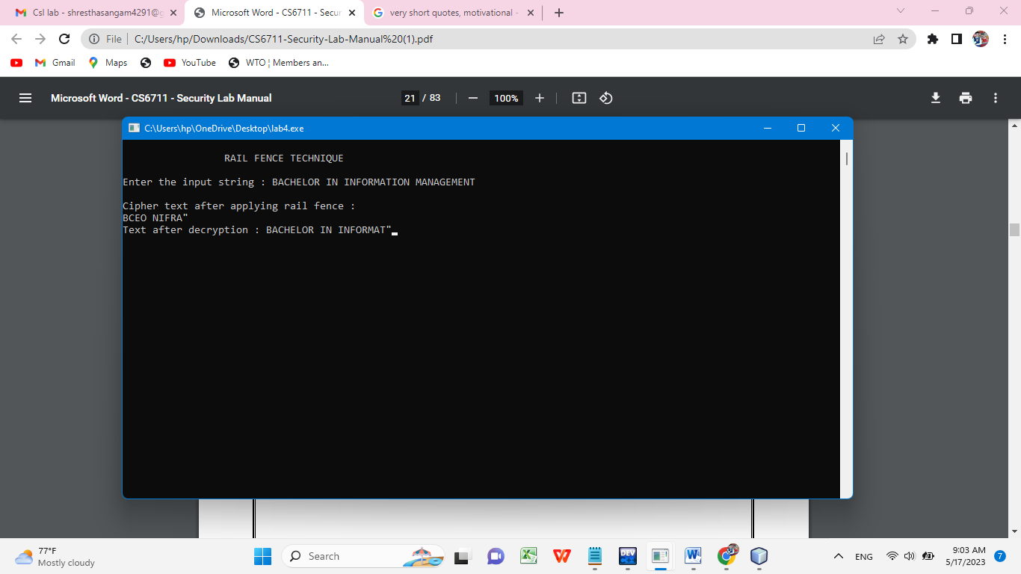

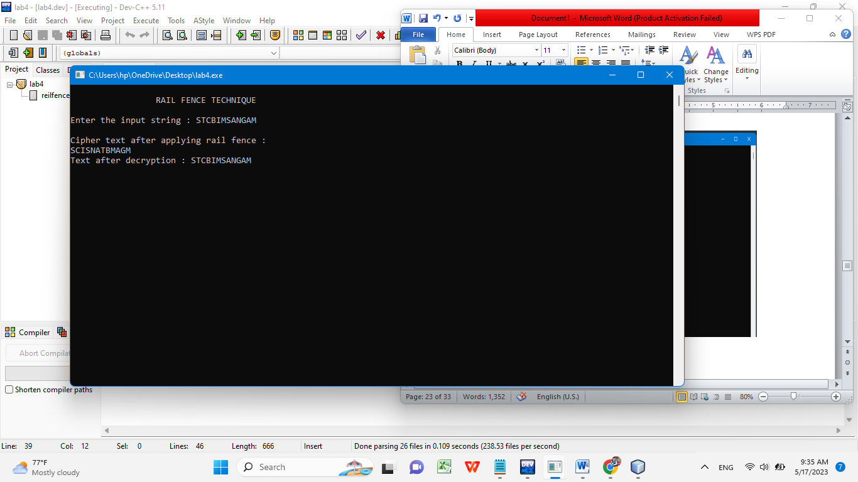

RESULT: Thus the Rail fence algorithm had been executed successfully.

EXPERIMENT NO.6

TITLE: IMPLEMENTATION OF DES

AIM:To write a C program to implement Data Encryption Standard (DES) using C Language.

DESCRIPTION:
DES is a symmetric encryption system that uses 64-bit blocks, 8 bits of which are used for parity checks. The key therefore has a "useful" length of 56 bits, which means that only 56 bits are actually used in the algorithm. The algorithm involves carrying out combinations, substitutions and permutations between the text to be encrypted and the key, while making sure the operations can be performed in both directions. The key is ciphered on 64 bits and made of 16 blocks of 4 bits, generally denoted k1 to k16. Given that "only" 56 bits are actually used for encrypting, there can be 256 different keys.
The main parts of the algorithm are as follows:
- Fractioning of the text into 64-bit blocks
- Initial permutation of blocks
- Breakdown of the blocks into two parts: left and right, named L and R
- Permutation and substitution steps repeated 16 times
- Re-joining of the left and right parts then inverse initial permutation

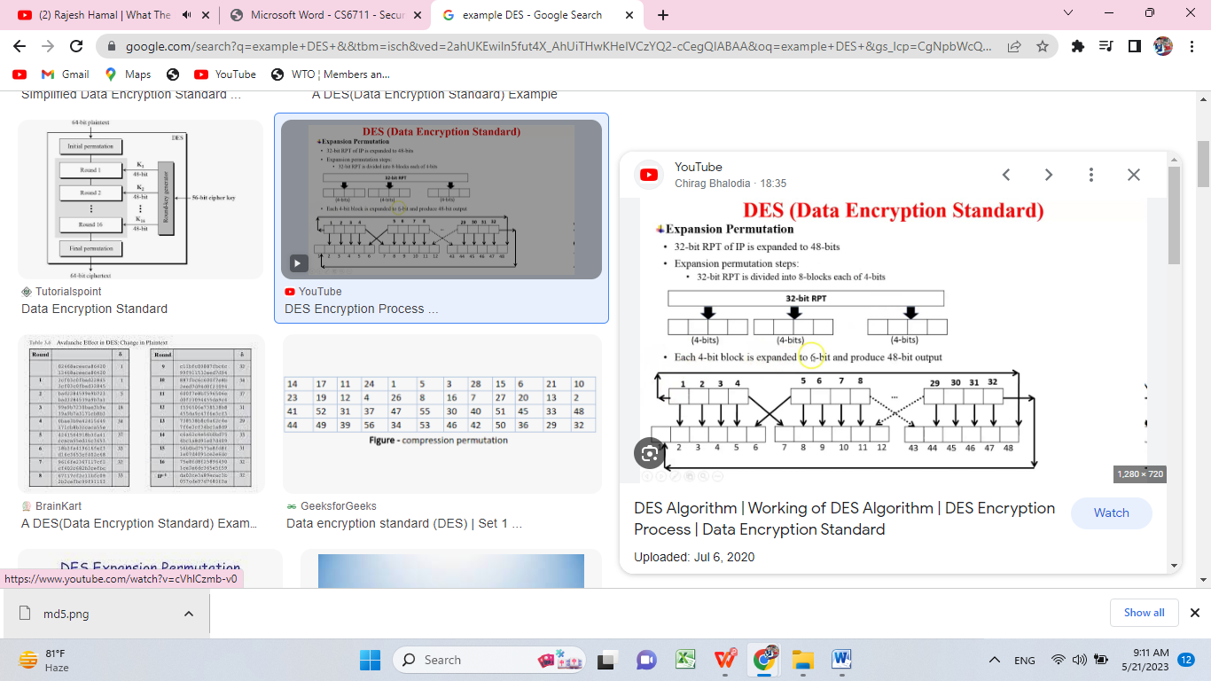

ALGORITHM:

STEP-1: Read the 64-bit plain text.
STEP-2: Split it into two 32-bit blocks and store it in two different arrays.
STEP-3: Perform XOR operation between these two arrays.
STEP-4: The output obtained is stored as the second 32-bit sequence and the original second 32-bit sequence forms the first part.
STEP-5: Thus the encrypted 64-bit cipher text is obtained in this way. Repeat the same process for the remaining plain text characters.

